FBV-161 | BANDPASS FILTER

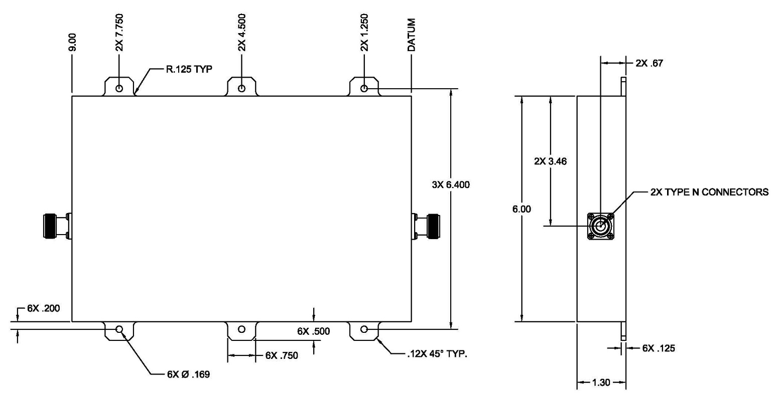

ELECTRICAL CHARACTERISTICS

Passband Insertion Loss, 243-270 MHz ................................ 1.5 dB max. VSWR, 243-270 MHz ................................................................. 1.6:1 max. Input Power .................................................................23 dBW min. 200 W Stopband, 0-218 MHz.............................................................. 60 dB min. Stopband, 292-318 MHz.......................................................... 70 dB min. Stopband, 318-1000 MHz......................................................... 60 dB min.
MECHANICAL CHARACTERISTICS

Connectors .........................................................................Type N Female Size, Excluding Connectors and Mounting Feet……… 9” x 6" x 1.35"
Weight ...................................................................................... 3.5 pounds
Environment ......................................................................... Weatherproof

REV: 12/4/2019

